Daily Planner

2023

Priority of the day:

Grateful for:

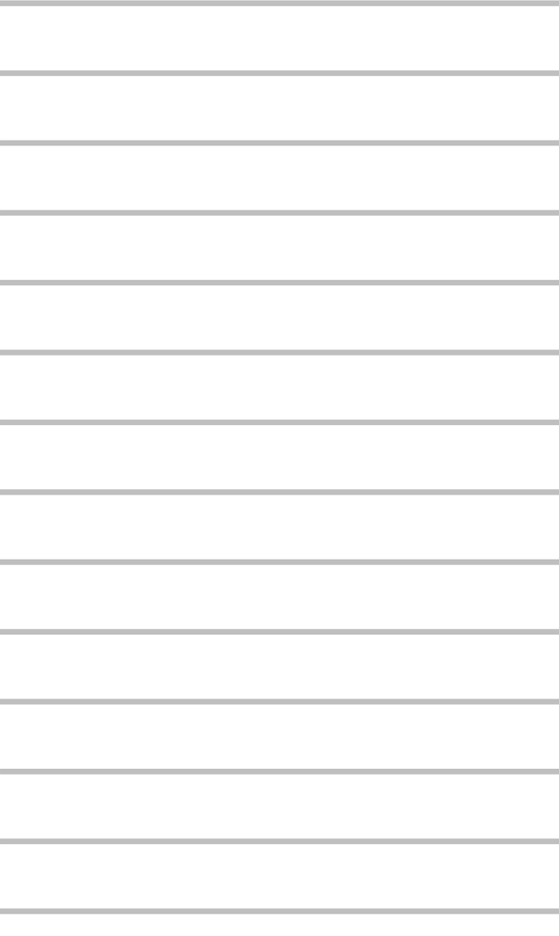 Today's Tasks

Ideas:

Appointments

Water Intake         Reminders & Notes

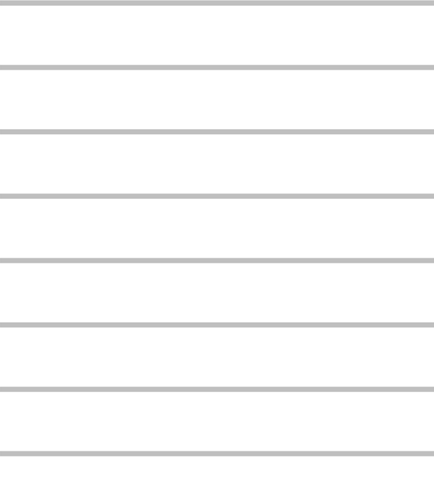

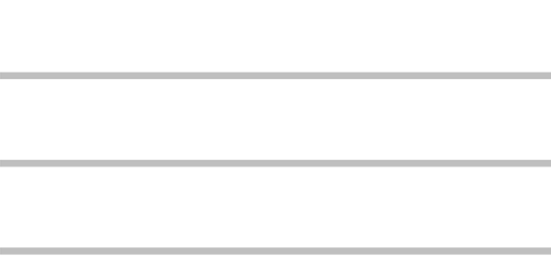

To Call/ E-Mail: